Topic 1. Theoretical Foundations of Digital Finance
Since the second half of the XX century, information technologies are acquiring an increasingly significant role in the economic development of many countries of the world. Unified Institute formational economic space, the formation of which was a cart can be due to scientific and technical progress, contributing to economic growth and higher productivity, the creation of innovative job creation and digital assets, the empowerment of citizens, improve access to global markets and improve the competitiveness of enterprises, improve the quality of public services, etc.
It is believed that the concept of "digital economy", in relation to the use of modern information technologies (digital) in economic processes and their management, was introduced by N. Negroponte in 1995. The advantages of the digital economy, in the opinion of N. Negroponte, are: lack of physical weight of products , which is replaced by information volume, lower resource costs for the production of electronic goods, a much smaller area occupied by products, as well as the almost instantaneous movement of goods through the Internet (in this case, of course, we are talking about specific digital goods). Some key properties of the digital economy are presented in table. 1.
Table 1. Main characteristics of digital economy
Characteristic | Impact on the development of the economy as a whole
Economic activity focuses on digital economy platforms | Interaction between economic entities is facilitated , costs (primarily transactional) are reduced , additional functionality is provided for both suppliers and consumers, their cooperation is improved, which reduces the cycle time for developing new products and bringing them to market, contributes to the creation and distribution of innovative products and decisions
Personalized service models are formed | Targeted internet marketing, 3D printing and other digital technologies make it possible to personalize the production and sale of goods and services, taking into account the requirements and needs of each specific client, which ultimately helps to save resources (by coordinating the structure and volume of supply and demand) and an increase in the quality and standard of living of the population
Direct interaction between producers and consumers is carried out | Prerequisites are created for reducing the chains of intermediaries between the manufacturer and the end user, building effective production and consumer cooperation
There is a proliferation of "shared economy of use" | Comprehensive digitalization and acceleration of communications create prerequisites for the erosion of traditional property relations, the development of legal practices for using the theoretical institutional concept of the “bundle of property rights”. The phenomenon of joint ownership of goods (especially technically complex and expensive, for example, cars) is developing , which can radically reduce the costs of end users.
The role of the contribution to the economic activity of its individual participants is growing | The development of small and medium-sized businesses, as more flexible and mobile, plays a significant role in business processes; the accelerated promotion of innovative startups is carried out ; the sector of "economy of individuals" is expanding and there is a tendency for the growth of "atomization" of the structure of the economy

The digitalization of business, which began with local in-house and corporate projects, is gradually acquiring a global scale, and large players of digital business have taken the first positions in the world. Thus, Apple, Alphabet, Microsoft, Amazon and Facebook are among the most valuable companies in the world by market capitalization. The most expensive non-US company on this list is the Chinese internet seller Alibaba Group. In addition, today examples of "digital ecosystems" are in various other industries and companies.

At the same time, the digital economy is inherently both inter- and transnational. Therefore , despite the desire to protect the national digital space, which is demonstrated by the governments of many countries, at the same time, there is an opposite trend associated with the unification of technical standards and regulatory rules in this area. For example, the European Union has over 400 million Internet users, but its market is still fragmented.
In this regard, the leaders of the EU countries are actively working to create a single digital market for this integration association. Similar problems can arise at the level of individual, rather large, countries. For example, India has over 460 million Internet users. But the Indian digital economy is multilingual (financial transactions in it are carried out in several languages), which negatively affects the functioning of the digital market.
The explosive growth of social networks, the increase in the number of smartphones, the facilitation of broadband Internet access, and the proliferation of machine learning and artificial intelligence technologies are changing the modern world. The digital transformation of organizations, both commercial and non-commercial ( including government), is a reaction to the development and active dissemination of new information digital technologies around the world . At the same time, proceeding from the paradigm of progress prevailing in science since the Renaissance, we believe that the main goal of the development of the digital economy is to improve the life of the population by increasing the quality of goods and services produced using modern digital technologies, as well as their availability.
The effective development of markets in the digital economy is possible only with the availability of advanced technologies, therefore, measures to stimulate it should be focused on two areas. The first is institutions; their restructuring and modernization is required to create the conditions for the development of the digital economy (regulatory regulation of digital markets and digital production, training of personnel with digital competencies, etc.). The second is the technical infrastructure (data transmission networks, data centers, software services, etc.), the creation of which requires not only significant efforts, but also investments.

The whole world is embraced by the idea of digital transformation. In the modern world, digital technologies play an increasingly important role in the development of countries' economies. Digital technologies have given a number of advantages - simplified access of the population and business to public services, accelerated exchange of information, the emergence of new opportunities for doing business, the creation of new digital products, etc.
Over the past decades, the world has been rapidly moving towards a new type of economy, where digital technologies are becoming the main tool for its formation. The expansion of the role of information technology in the work of the private and public sectors is the basis for the transition to a digital state.
According to forecasts of leading world experts, by 2020 25% of the global economy will be digital, and the introduction of technologies for digitalizing the economy, allowing the state, business and society to effectively interact, is becoming an increasingly large-scale and dynamic process.
The government and state bodies of Kazakhstan, realizing the importance of informatization of society and the development of digital technologies in determining long-term economic growth, are actively involved in the development of this area as one of the key directions of state policy.
The state program "Informational Kazakhstan-2020", approved in 2013, became the foundation for the digital transformation of the economy of Kazakhstan. It contributed to the development of the transition to the information society, the improvement of public administration, the creation of institutions of "open and mobile government", the increase in the availability of information infrastructure not only for corporate structures, but also for the citizens of the country. According to the results of three years of implementation of the State Program, it has already been implemented by 40%. However, the rapid development of information technologies on a global scale dictates its own rules and Kazakhstan takes the next step - it develops a new state program "Digital Kazakhstan".
The main goal of the new state program is the progressive development of the digital ecosystem to achieve sustainable economic growth, increase the competitiveness of the economy and the nation, and improve the quality of life of the population. The implementation of the state program is carried out in four key areas: the implementation of the digital Silk Road (this is the development of a reliable, accessible, high-speed and secure digital infrastructure), the development of a creative society (this is the development of competencies and skills for the digital economy, work to improve the digital literacy of the population, the training of ICT specialists for industries), digital transformations in sectors of the economy (this is the widespread introduction of digital technologies to increase the competitiveness of various sectors of the economy), the transition to a proactive state (this is an improvement in the electronic and mobile government system, optimization of the provision of public services).
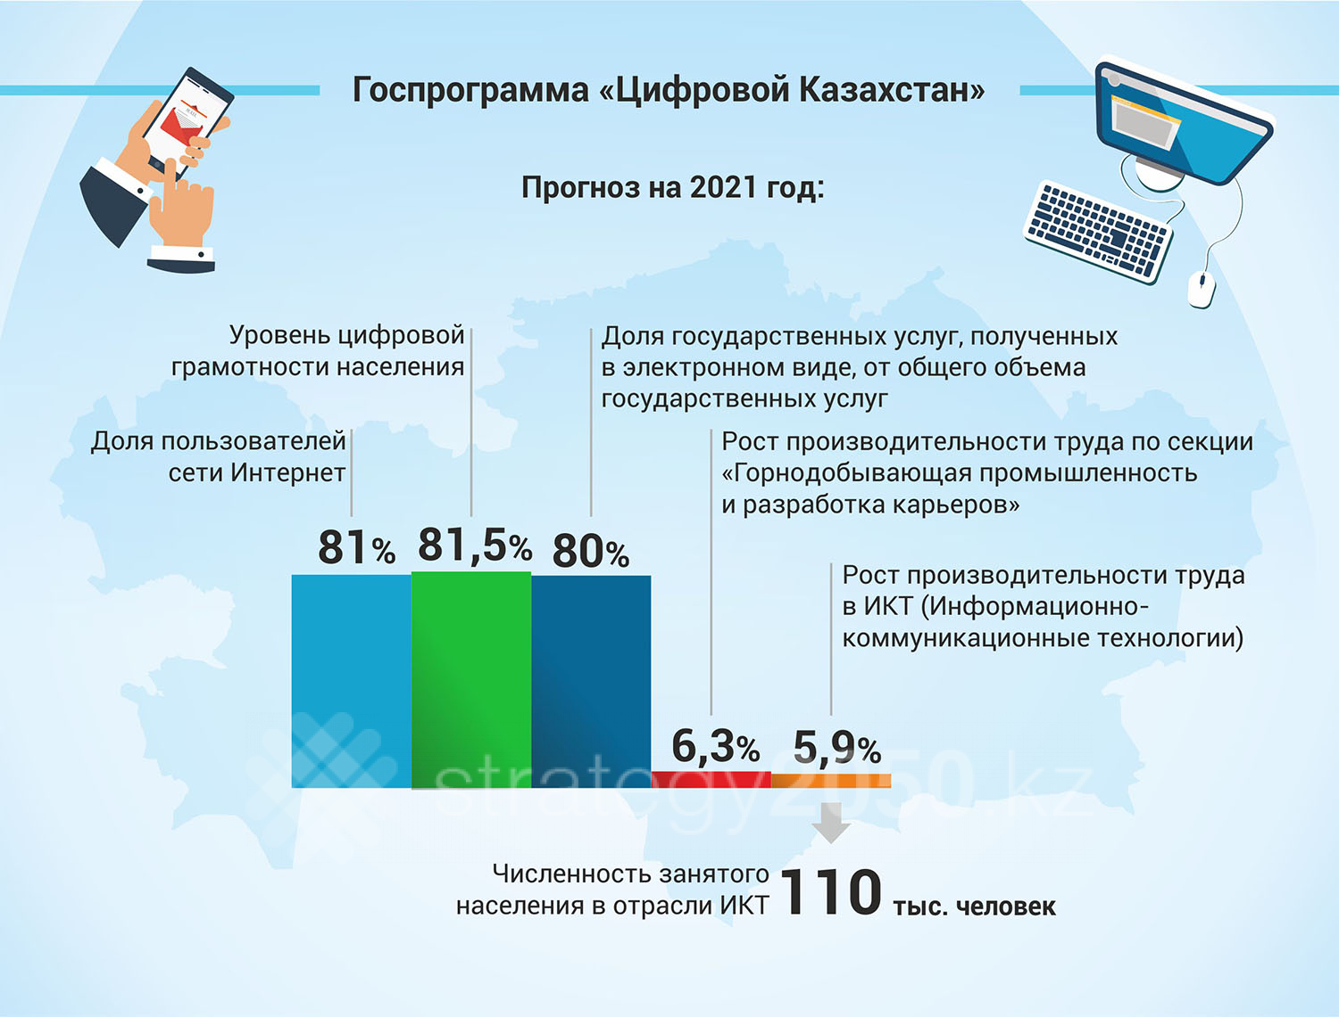

World experience
Currently, the idea of ​​digital transformation covers the whole world and in many countries digitalization is a strategic development priority.
Today, more than 15 countries around the world are implementing national digitalization programs: Denmark, Norway, Great Britain, Canada, Germany, Saudi Arabia, India, Russia, China, South Korea, Malaysia, Singapore, Australia, New Zealand and Kazakhstan.
According to Ruslan Ensebaev, Chairman of the Board of JSC National Infocommunication Holding Zerde, China, Singapore and South Korea are among the leading countries in the digitalization of national economies.
China, through its Internet Plus program, integrates digital and traditional industries. Singapore is shaping the Smart Economy, Canada is creating an ICT hub in Toronto, driven by ICT. And South Korea in the Creative Economy program focuses on the development of human capital, entrepreneurship and the dissemination of ICT achievements, while Denmark focuses on the digitalization of the public sector.
The most prominent example of a digital privatization approach is Singapore. So, in 2014, the state initiated the development of the Smart Nation concept and invited business and the expert community to cooperate to clarify and implement it.
Thus, one of the key initiatives identified initially is the development of a national sensor network to build a “smart city”. For each of the tasks, the state organizes a tender to select a contractor to develop a technical solution. Participation in the tender is open to all participants who meet the requirements of the briefing: thus, the state provides a focus not only on large business, but also on attracting small and medium-sized businesses. It is noteworthy that in 2015-2016. more than half of the contracts were signed with small and medium-sized businesses.
The state can provide a "digital leap" in the country through the accelerated development of specific technologies. In such cases, the state assumes the role of an investor, determining the key, most promising areas of financing, based on an assessment of long-term return on investment, competitive position, trends, and also invests in fundamental conditions for success, such as education and retraining of personnel.
In South Korea, with the active position of the state, support companies begin to independently invest in breakthrough digital technologies. Thus, one of the largest telecom operators in the country, SKT, has indicated its intention to invest more than $ 4 billion in artificial intelligence and Internet of Things technologies. The operator notes the need for partnerships in the development of new technologies, and also plans to attract local startups to develop point solutions.
Digitalization rating
The Digital Evolution Index 2017 reflects the progress in the development of the digital economy in different countries, as well as the level of integration of the global network into the lives of billions of people.
According to their research, Singapore, the United Kingdom, New Zealand, the United Arab Emirates, Estonia, Hong Kong, Japan and Israel have become the “digital elite”: these countries are characterized by a high level and fast pace of digital development. With this speed of innovation, these progressive markets can serve as an example of successful technological progress and guidance for future growth.
Norway, Sweden, Switzerland, Denmark, Finland, Singapore, South Korea, Great Britain, Hong Kong, USA are in the TOP-10 countries with the most developed digital economy.
Having analyzed the current state and growth rates of the digital economy in each state, the authors of the study divided the countries into 4 groups:
Leaders: Singapore, UK, New Zealand, UAE, Estonia, Hong Kong, Japan and Israel demonstrate high rates of digital development, maintain it and continue to lead in the diffusion of innovations.
Slower Growth: South Korea, Australia, as well as countries in Western Europe and Scandinavia have shown strong growth for a long time, but now they have noticeably slowed down the pace of development. Without the introduction of innovations, these states run the risk of lagging behind the leaders of digitalization.
Forward-looking: Despite the relatively low overall level of digitalization, these countries are at the peak of digital development and are showing steady growth rates, which attracts investors. China, Kenya, Russia, India, Malaysia, Philippines, Indonesia, Brazil, Colombia, Chile, Mexico have the potential to take the lead.
Challenging: Countries such as South Africa, Peru, Egypt, Greece, Pakistan face serious challenges associated with low digital development and slow growth.
In the key world ranking of ICT development, calculated under the auspices of the United Nations - ICT Development Index - Kazakhstan in 2016 ranked 52nd out of 175, having not changed its position since 2015. As a result of the implementation of the Program and other strategic directions, the country will rise in the ranking to 30th place by 2022, 25th place by 2025 and to 15th place by 2050.
Kazakhstan is also a catching-up country in the e-intensity rating of the international consulting company The Boston Consulting Group in terms of the current level of digitalization. To overcome the catching-up status in the Program, revolutionary, breakthrough measures are required in all areas of digitalization on the agenda of the countries of the world.
These areas include the digital transformation of traditional sectors of the economy, the development of human capital, the digitalization of the activities of government agencies, the development of digital infrastructure, as well as a breakthrough in the development of an ecosystem of entrepreneurship in the field of digital technologies and, as a result, a change in production models and added value in the real sector of the economy.
At the same time, Kazakhstan does not start from scratch. In the 90s, a state program for accelerated industrial and innovative development was launched, the Bolashak international education program was initiated, and in 2005, the formation of an "electronic government" began. Also, a number of elements of the innovation ecosystem have already been created in Kazakhstan, the SEZ "PIT" Alatau ", AOO" Nazarbayev University "are operating, the international technopark Astana hub is being launched. 3/4 of the adult population of our country has a basic level of digital literacy, more than 3/4 have access to the Internet. This is a significant base from which we can build on in the implementation of the Program.
In his Address, the President of the country noted that the development of the digital industry will provide an impetus to all other industries and instructed the Government to keep this issue under special control. In this regard, the Head of State set the task of developing new industries that are created using digital technologies.
Thus, the share of information technology in the gross domestic product of South Korea is 9%, in Japan - 5.5%, in China and India - 4.7%, and in Uzbekistan - only 2.2%. According to the results of the report of the International Telecommunication Union in the index of information and communication development in 2017, Kazakhstan ranks 52nd among 176 countries of the world. At the same time, in the CIS region, Kazakhstan is one of the three leaders, ranking third after Belarus (32nd) and Russia (45th).
Towards digitalization together
In October 2017, at a meeting of the Supreme Eurasian Economic Council, the heads of the EAEU member states approved the main directions of the digital agenda until 2025, and also supported the initiative of the President of Kazakhstan to hold a special meeting on digitalization of the EAEU economy.
And such a meeting took place on February 2 this year in Almaty, where the prime ministers of the CIS countries, delegations of the EAEU member states and more than 800 domestic and foreign experts took part to discuss the most pressing topic of the new time.
Former Prime Minister of the Republic of Kazakhstan Bakytzhan Sagintayev in his speech at the digital forum emphasized that although each EAEU country moves in its own way in the development of high technologies, it is important that there is an opportunity to integrate in the digital sphere. We are talking about a mutually beneficial exchange of experience and innovations between the centers "Skolkovo", "Innopolis", the Belarusian "Park of High Technologies", Kazakhstan's Nazarbayev University, the free economic zone "Astana-Technopolis" and the new International Technopark, which is now being created on the basis of "Expo-2017" IT startups, etc.
"The main goal is to build a unified innovation ecosystem of the EAEU countries, capable of coordinating and promoting the Union on the external circuit to attract venture capital funds and startups from all over the world," Bakytzhan Sagintayev said.
The prime ministers of Armenia, Belarus, Kazakhstan, Kyrgyzstan, Russia and Uzbekistan, as well as official representatives of Azerbaijan and Tajikistan, supported the head of the Kazakh government that it is necessary to jointly develop the digitalization of the economy.
The past forum "Digital Agenda in the Era of Globalization" clearly confirmed the commitment to joint implementation of digital transformations in national economies within our common market and the accelerated development of competitiveness on a global scale.
According to our expert, the EAEU countries are, figuratively speaking, "in the last car of the outgoing digitalization train."
“In other words, despite some differences in basic beginnings and approaches, we are actually at the starting point and understand the practical feasibility of synchronizing digital processes in our countries. Certain difficulties are created by the heterogeneity of the EAEU countries in the development of the basic IT infrastructure and the maturity of professional personnel, the level of penetration of mobile technologies, the development of electronic services provided by the state to the population, e-commerce, legislative support for start-ups and venture financing. I am sure that the EAEU has the capabilities, resources and competencies to compete with other states and integration associations for its place in the digital world, ”Ruslan Ensebayev said.
Pros of digitalization
According to preliminary estimates, the direct effect of the digitalization of the economy by 2025 will create an added value of 1.7-2.2 trillion. tenge, thus providing a return on investment by 4.8 - 6.4 times by 2025 to the total volume of investments, taking into account private investments.
Digitalization has an impact on all sectors and will lead to a change in the structure of the economy of Kazakhstan as a whole by diversifying and unlocking the potential of non-resource industries, stimulating start-up activity and opening “new industries”. At the same time, the degree of influence of digital technologies in different industries is not uniform - the greatest potential for value creation is assumed within the framework of traditional sectors of the economy of Kazakhstan, including the raw materials sector, but fundamentally new opportunities for creating value in e-commerce, the IT sector and the financial industry are also opening up.
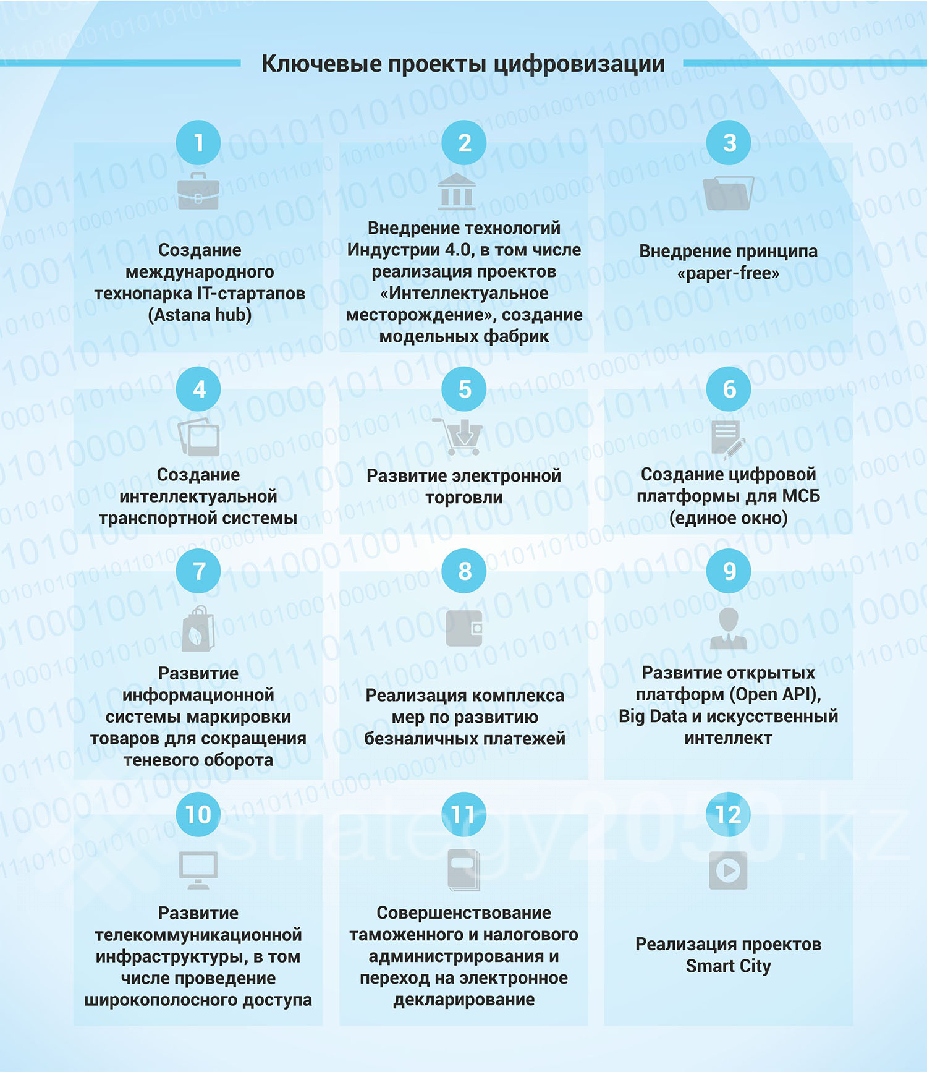

An important result of the implementation of the Program will also be the acceleration of Kazakhstan's entry into the top 30 in the UN ICT Development Index.
Successful implementation of the impact of digitalization on the growth of production volumes of enterprises by 2022 will mean the following achievements:
Raising the level of labor productivity to the level of the TOP-30 countries of the world in each of the priority sectors.
Competitive export production in priority sectors.
Capitalization of the largest companies has reached a fundamentally new level.
Developed local e-commerce.
Reducing the share of the shadow economy to a level comparable to the TOP-30 countries of the world.
The widespread introduction of digital technologies will give impetus to the development of traditional basic industries by ensuring productivity growth, increasing their competitiveness, including in the international market. Thus, as a result of digitalization, the growth of domestic exports to foreign markets will be ensured both in the raw materials industries and in the agro-industrial complex, which, in turn, will lead to an increase in the capitalization of the largest manufacturing companies. Also, to increase productivity, the Program provides for the implementation of a set of measures for the technological re-equipment of basic industries, where elements of Industry 4.0 will be applied.
Kazakhstan, implementing an integrated approach to digitalization, nevertheless settled on such basic elements as digitalization of the mining industry and agro-industrial complex, further development of digital public services and ICT infrastructure. In the area of ​​special attention is the development of human capital and the creation of an innovation ecosystem.
That is, we are talking about five main directions of the Digital Kazakhstan State Program, and the result will depend on the joint efforts of the state and business, as well as the involvement of every citizen of our country.
Digitalization of personnel
Digitalization is significantly ahead of the existing system of production requirements for the composition of professions employed in the labor market.
In order to train professional personnel for sectors of the economy with a set of digital skills "by default", the subject "Information and communication technologies" has already been introduced in all specialties.
For the development of technical and vocational, higher and postgraduate education in order to bring industry and education closer together, measures are envisaged for the creation of ICT departments of universities at enterprises, as well as centers of competence.
It is also planned to update educational programs based on professional standards and labor market requirements for new in-demand professions, such as Data Science, Robotics, Genomics, Nanoelectronics and Nanomechanics, highly qualified developers for product development using technologies: Artificial Intelligence, Iot solutions, Blockchain, Additive technologies, BIM, etc.
The digital economy requires digital skills in the population to reap its benefits. At the same time, at present, the level of computer (digital) literacy of the population is 76.2%, and its growth is necessary in the coming years.
At the moment, the Ministry of Education and Science of the Republic of Kazakhstan is already introducing a number of initiatives: the subject "Information and Communication Technologies" has been introduced in grades 3-4, which forms general basic knowledge of working with modern information technologies for their effective use in studies and everyday life. There are 372 robotics clubs that teach the general basics of programming in the framework of robotics.
In technical and vocational, higher, postgraduate education, according to the Ministry of Education and Science, on the basis of three specialties, the subject "Information and Communication Technologies" has been introduced, which forms students' basic knowledge of the use of ICT in practice within the framework of the chosen profession. Professional standards are being developed, which will become the main basis for educational programs of technical and vocational, higher, postgraduate education.
Also, to date, for the period 2014-2016, 14.5 thousand educational grants were allocated for the training of specialists in ICT specialties, and the graduation for the same period amounted to 94 thousand people.
Nowadays, much attention is paid to the development of the innovation ecosystem. Astana Hub was created on the basis of Astana-EXPO, work is underway to select startups that will undergo acceleration on its basis.
Already this year, it is planned to develop and bring 33 startups to the level of ready-made companies. Until 2022 - about 300 companies. Also, 3 R&D laboratories (Research and Development) will be opened with partners of the Zerde holding, large international IT companies.
Zerde is also involved in the work on the development of human capital. The study of IT competencies will be introduced into programs of all levels of education, by 2025 it is planned to introduce the study of programming basics in the elementary grades in 100% of Kazakhstani schools, already in 2018 the number of grants for IT specialties and the opening of IT departments at the main enterprises of the Industry will be increased 4.0. In addition, this year it is planned to teach about 400 thousand businessmen and ordinary citizens the necessary IT competencies.
In order to expand educational opportunities for everyone who wants to acquire the necessary skills, a national open education platform will be created, which will provide online courses, first of all, providing basic training in demanded engineering and technical areas, with the involvement of large teams of the best professors of Kazakhstani universities and production representatives.
Barriers to digitalization
The basis for the digitalization of the economy is production. The concept of digital production is a set of tools for optimizing the workflow through software and hardware solutions. Quite simply, digitalization is nothing more than the transition from analog to digital. This process implies not only the replacement of production tools, but also the introduction of analytical systems that make production as profitable as possible. The digital economy is based on these tools. This is just a new stage in the development of the economy. Of course, each country has its own barriers in this direction.
“To briefly list the negative factors that one has to face, it is, first of all, the national mentality, which fears or completely rejects everything revolutionary new, add to this the laziness of the population and dependent expectations from social subsidies from the state. Government agencies, officials and representatives of the quasi-sector, unfortunately, still have a link to the raw materials sector of the economy, as less risky and more profitable without unnecessary costs, and in the majority of the business community, the “buy and sell” principle prevails over attracting innovations and the need for fast and flexible transformations, ”the expert notes.
Minister for Investment and Development of the Republic of Kazakhstan Zhenis Kassymbek at the international forum "Digital Agenda in the Era of Globalization" said that about 80% of manufacturing enterprises and 60% of mining enterprises today are at the level of semi-automated operations, or in an embryonic state with the transition to automated production, which corresponds to a low level of industrialization. Such data were obtained based on the results of a study in which about 600 enterprises of the manufacturing and mining industries were surveyed.
“We have identified the main barriers, that is, what are the main barriers for our enterprises today, in order to introduce digital industry technologies . Firstly, we were surprised and realized that there is an insufficient understanding of the economic benefits of the business itself from the introduction of elements of Industry 4.0, ”the minister said.
In addition, according to him, there are problems with the lack or lack of specialized personnel, infrastructure, insufficient development or lack of digital domestic solutions.
The problem also exists in the banking sector, where long-term loans necessary for business are practically inaccessible due to their high cost. Another obstacle was the devaluation of the currency, as a result of which many foreign technologies for Kazakhstani business became quite expensive.
The Minister of Information and Communications of the Republic of Kazakhstan, Dauren Abaev, spoke about the plans for 2018, identifying the main areas in which it is necessary to do the work outlined in the plan.
Among the performance indicators planned for the current year, the main ones are: an increase in the share of Internet users to 78%, an increase in the share of local content in IT services to 26%, the creation of at least 200 start-up companies supported by technology parks, incubators and accelerators. Including at least 33 startups must undergo acceleration in the Astana Hub Technopark.
At the same time, in 2018, the ministry will start implementing the project "Construction of fiber-optic communication lines in rural areas of the Republic of Kazakhstan"; the project will cover 1,249 villages until 2020.

